How to Clock In/Out of ExpressTime Kiosk

- Employees will enter their 4-digit pin and password and click Clock In/Out.

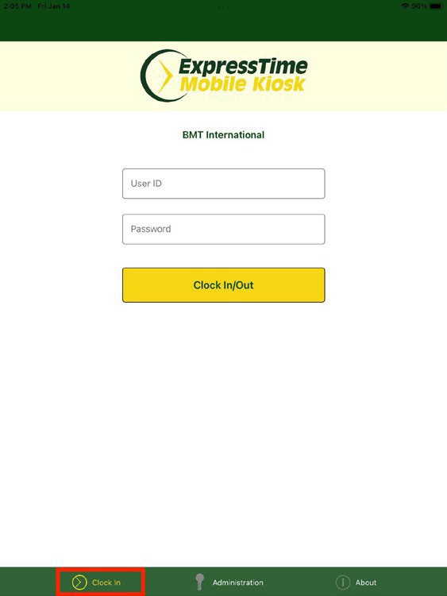-User ID: 4 digit pin or Administrative User ID
-Password: Password

- This will open the clock in/out screen. Tap the schedule to clock in or tap Unscheduled Service to clock in if no schedule exist.
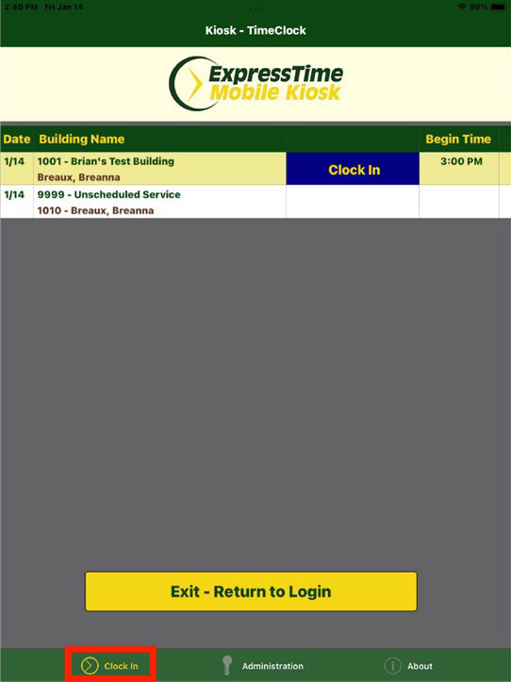

- Click Ok to complete the clock in process.
